

HUMAN COMPUTER INTERACTION

PROJECT PROPOSAL

PROJECT NAME:

E-commerce APPLICATION

GROUP MEMBER:

MANSOOR MUGHAL(9239)

**TASK ANALYSIS**

**GOAL:** To provide ease to the user by offering a platform for online shopping and give the user an interactive and easy to use application.

**PRECONDITION:**

* User must have an account for login.
* User need to know id and password.
* User have to select which category of shopping they will choose.
* User must know the basic know how of operating an e-commerce application.

**TASK:**

**User**

1. Register
2. Login
3. Choose a product
4. Select the product
5. View Shopping car
6. logout

**Admin**

1. Login
2. Add category
3. Add brand
4. Add customer
5. Add user
6. Add product
7. View user
8. View product
9. logout

**USECASE DIAGRAM**

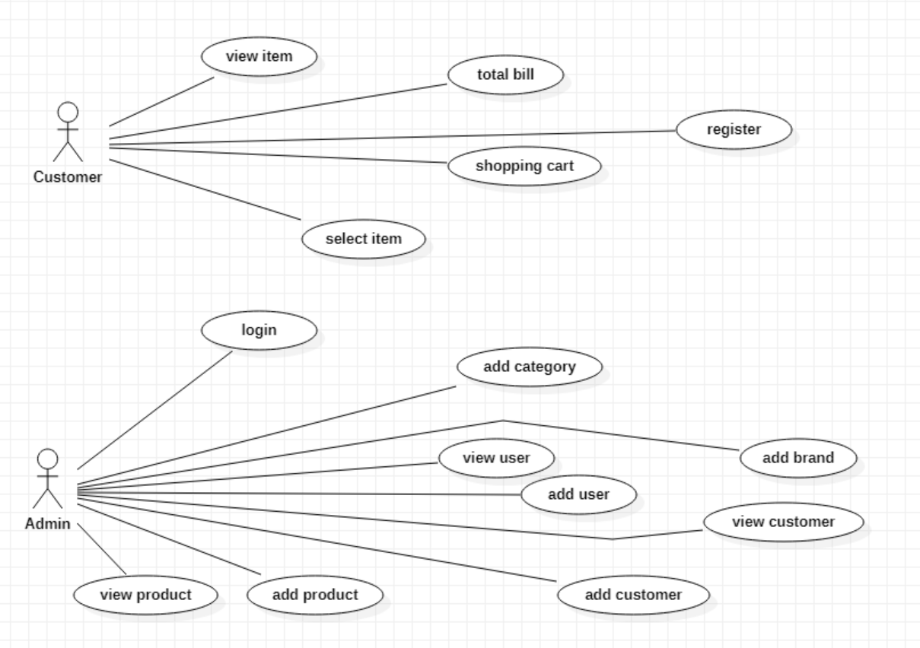

**STOARYBOARD**

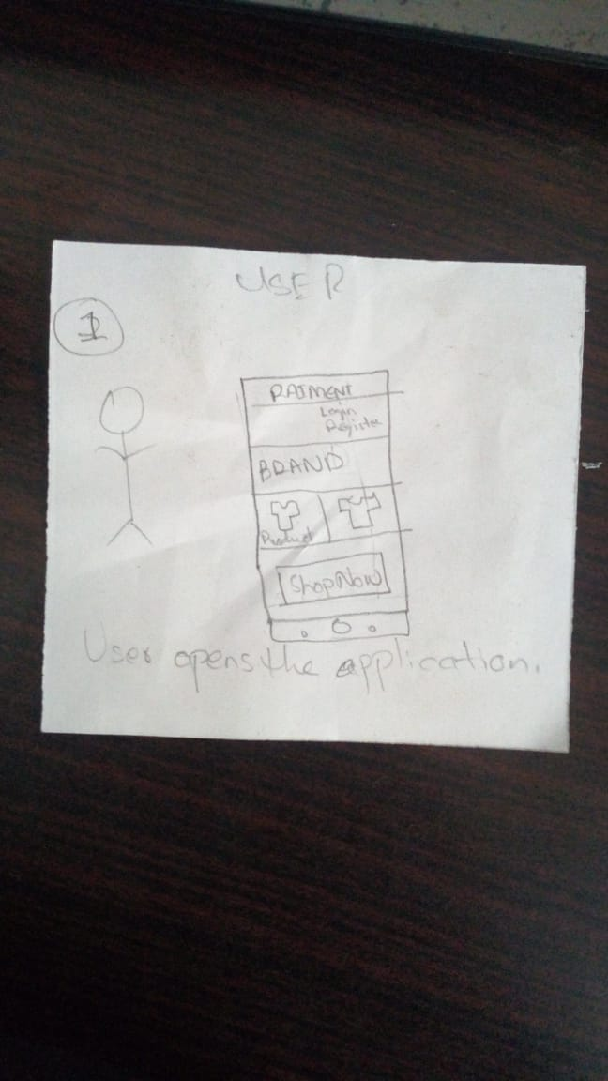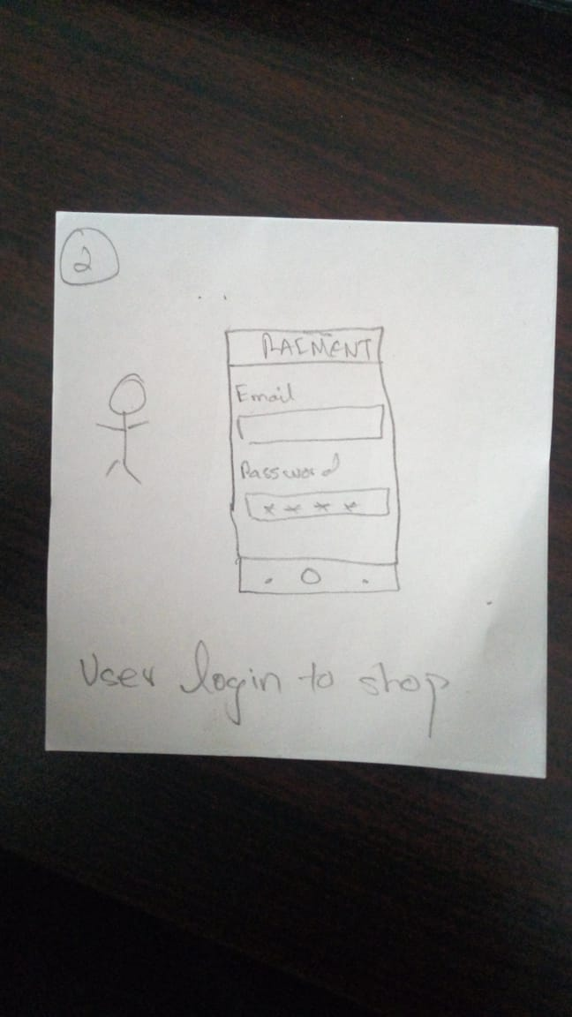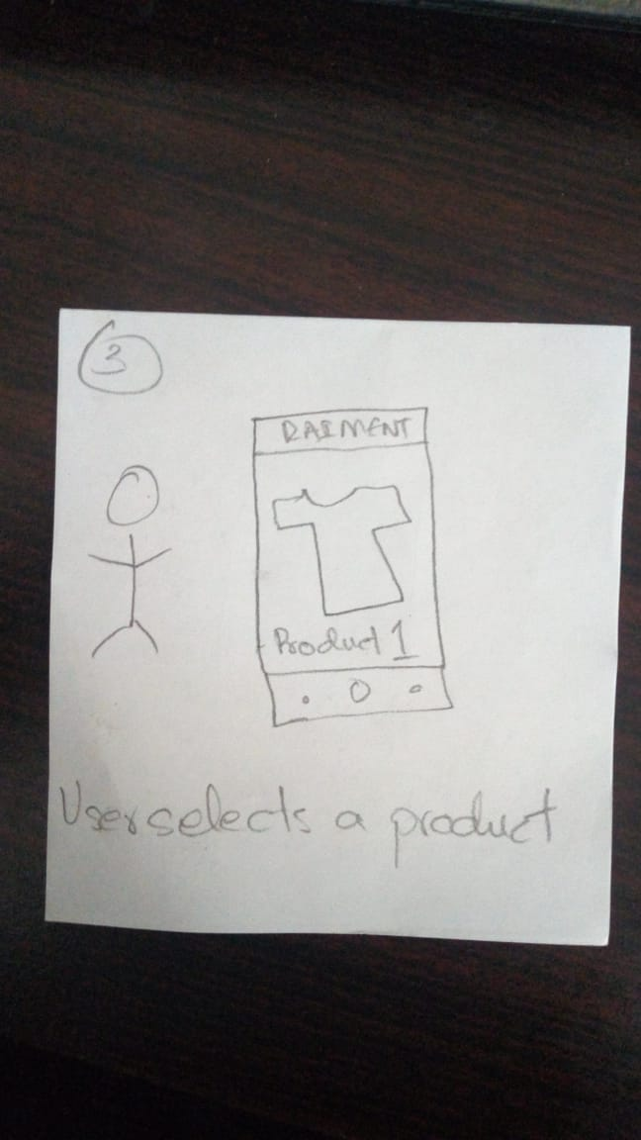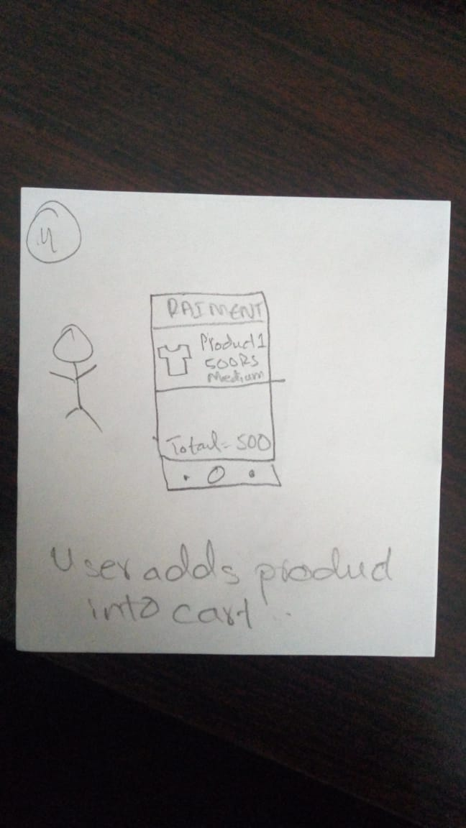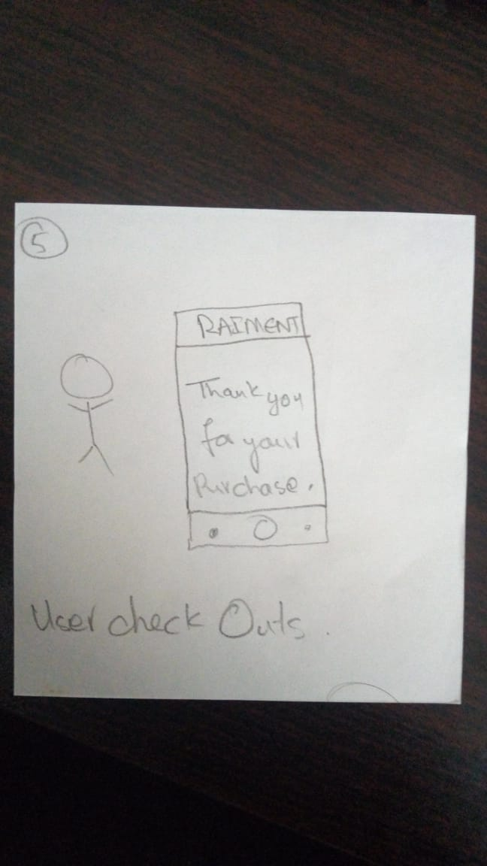

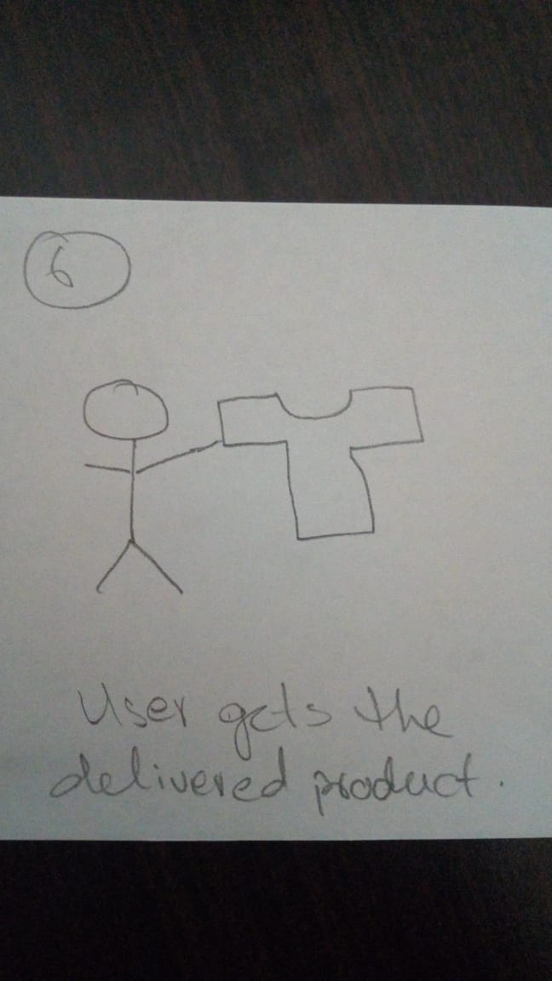

**PROTOTYPE**

**Login screen**

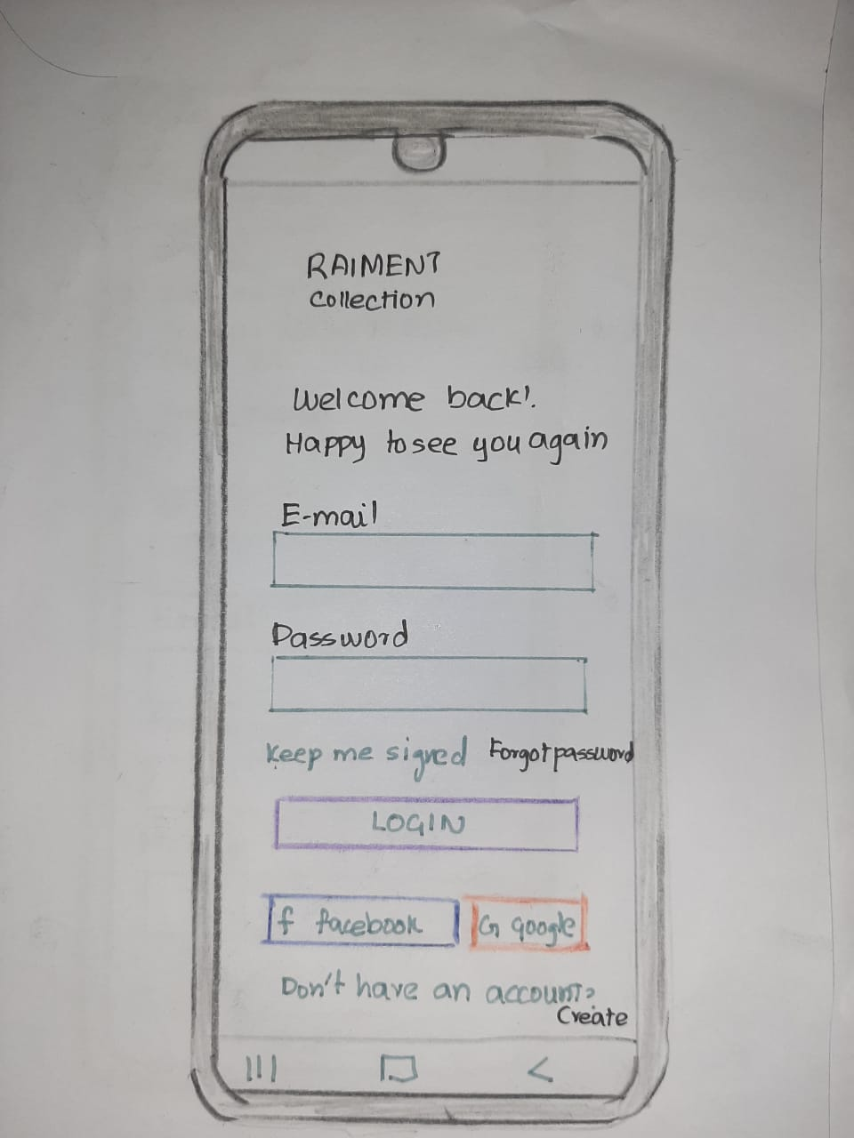

**Register screen**

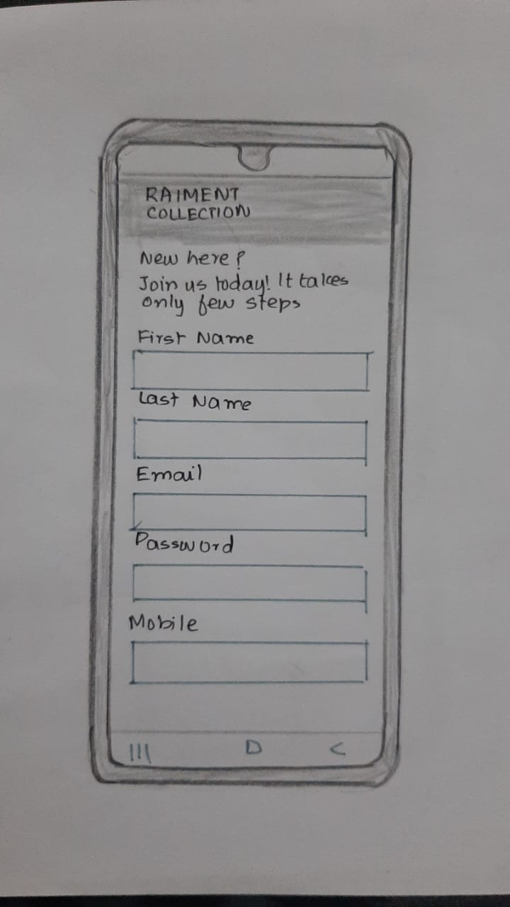

**Home screen**

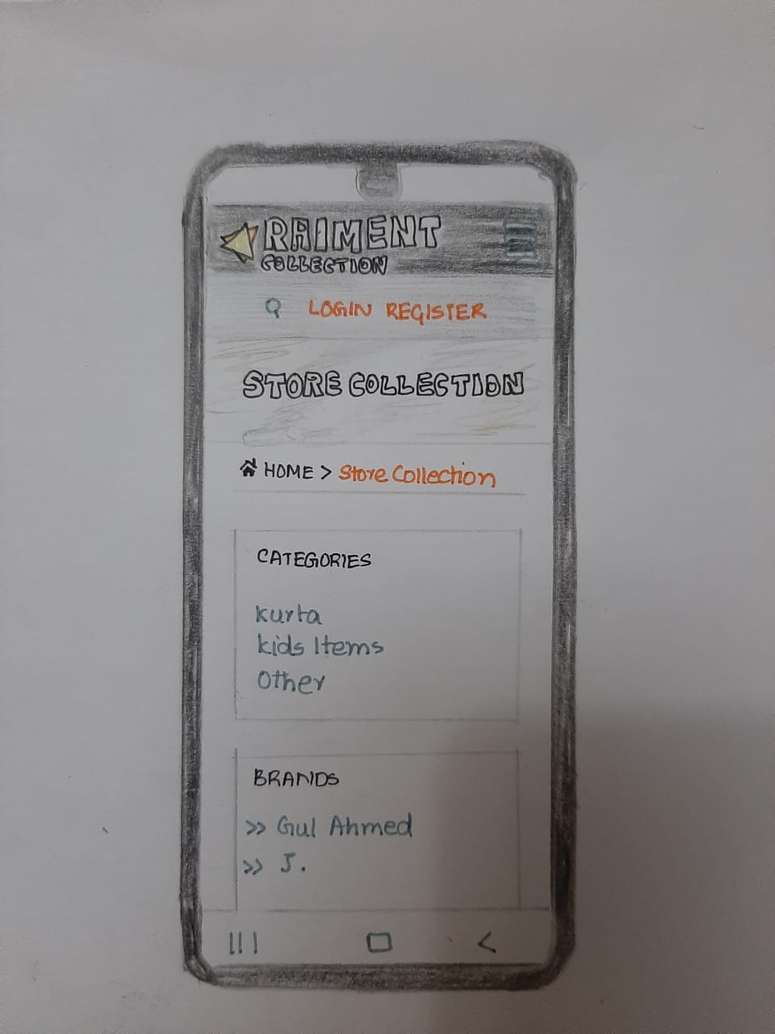

**Shop screen**

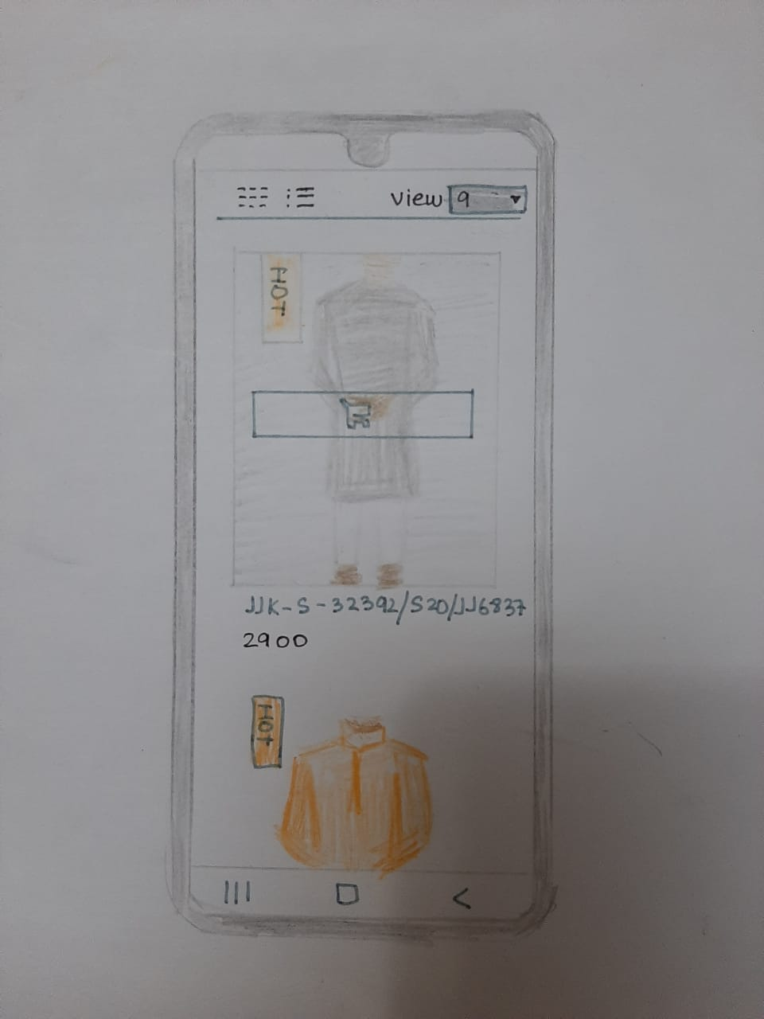

**Checkout screen**

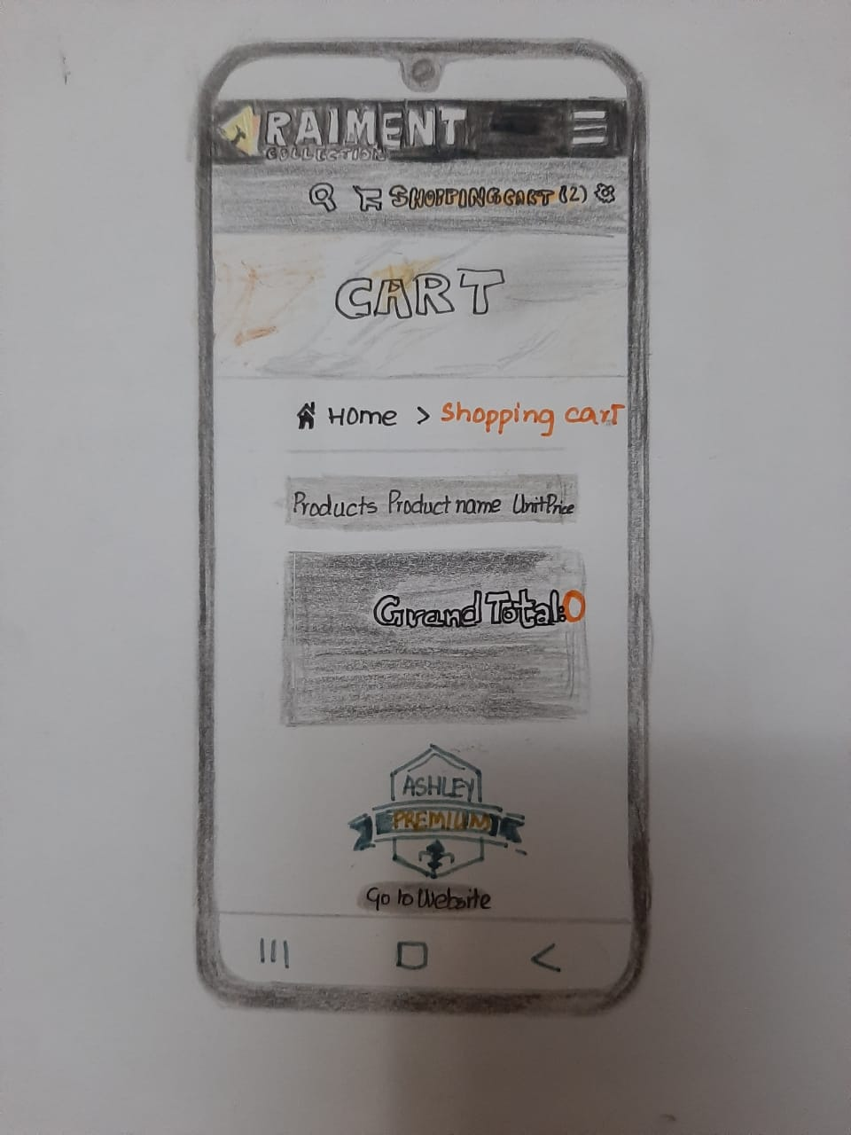

**Item viewing screen**

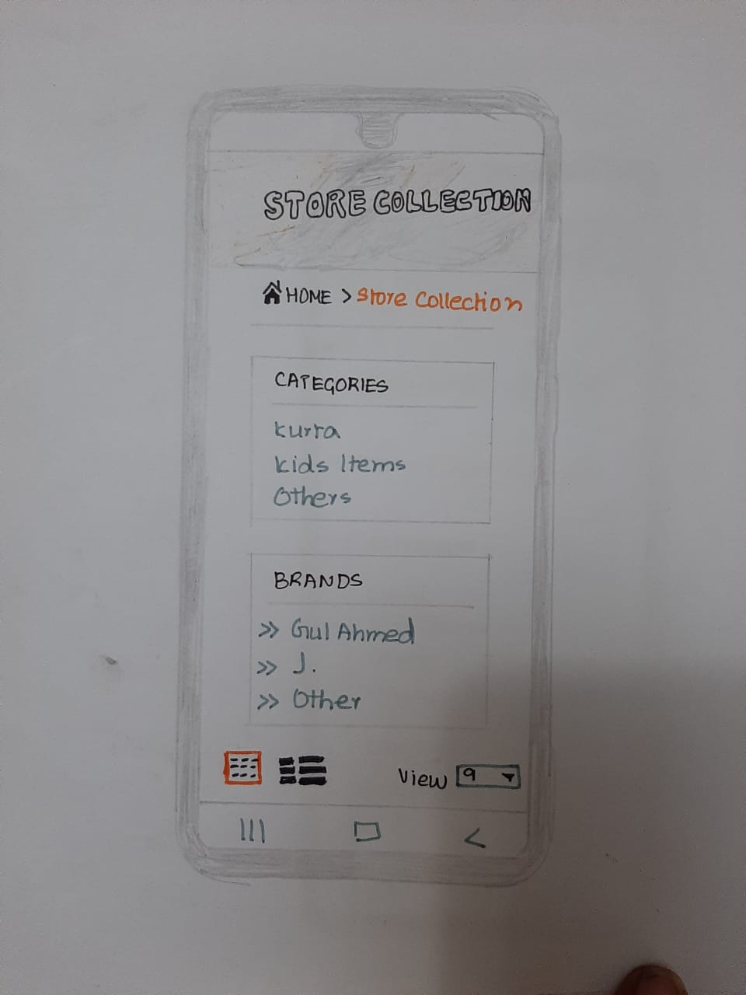

**category screen**



**Video link : https://1drv.ms/v/s!At3QEoq6HgKe0xXVf21VAyONzhLy?e=Uab0KZ.**

**PERSONAS**



**BIOGRAPHY:**

This is my Brandi.

She is 20 years old.

She is a doing masters from Maju currently.

She lives in Karachi.

**HOBBY:**

She is a food lover . She loves to visit different restaurants in order to taste different kinds of food. She also loves to travel new places. She loves to try different foods. She is such an intelligent person. She spends most of her in doing study and in her free time she loves to watch movies.

**INTEREST:**

She has interest in doing programming , explore multiple language regarding her field. She has also her real interest in android development, web designing, and many more. She loves to make mobile application and she explores and use many software related android application like adobe XD and many more.

**GOAL:**

She wants to make an application in which people can easily order clothes online in these hard times of corona virus.

**PROBLEMS:**

She faced many problem during the initial phase of development. She didn’t knew how to promote her brand. She had made the application but there were a few bugs in the ordering system and the product shown were also not loading correctly.

**IMPROVEMENT:**

To overcome the problem she took measures to ensure the quality of the application. She sorted out the bugs by working together with her team. She diligently put a lot of work programming and testing the application.

**FEEDBACK:**

From After few days , she complete her application by solving her problems and after that the application looks quite user-friendly , easy to use and attractive.



**BIOGRAPHY:**

This is Nina

She is 25 years old.

She is software engineer.

Works at Q/A game company.

**HOBBY:**

Reading books is her hobby. She has a huge collection of books. She is a book enthusiast.

**INTEREST:**

She is very in interested in books and hopes to make a book selling website one day. She agrees that a hard copy book is always better than a soft copy book because you can read it anytime and it doesn’t have a battery.

**GOAL:**

* Discovering new books/author’s to read.
* Finding unique stories.
* Cataloging new book collection

**PROBLEM:**

She started to make an application for it but faced many problems.

* Keeping track of series.
* Forgetting a book launch date
* Space for new books.

**IMPROVMENT:**

She never backed down from a challenge.

* She made a API for tracking launch date from websites.
* She hired a person to update the series.
* She bought a larger space for getting new books.

**FEEDBACK:**

After completion of application, she get good response form the users.



**BIOGRAPHY :**

She is Areesha she is 21 years old.

She lives in KARACHI ,PAKISTAN She is doing BSCS from PAFKIET

**HOBBY:**

She is pet lover, especially she loves cats ..she has two cats in her house and she loves to take care of them and after that she do her studies and help their fellows in studied. She loves to help other peoples. And in her free time she watches seasons on Netflix to make her mind relaxed

**INTEREST:**

Her interest is to make everybody life easier by making an application to track daily task so that people now how to use their time efficiently.

**GOAL :**

She has a mind to make a perfect application for everyday use and to keep track of daily tasks.

**PROBLEMS:**

She encountered many problems:

* The GUI was bugging
* The task couldn’t track the time
* The application wasn’t running in the background
* The pop up notification weren’t responding

**IMPROVEMENT:**

The improvement made were:

* She sorted the problem by making a responsive GUI for every mobile.
* She fetched the precise time from the region by online API.

**FEEDBACK:**

After removing the bugs her application was complete and she made a huge user pool online and the people were appreciating her work.



**BIOGRAPHY :**

She is AENI NAEEM.

She is 30 year old.

She is a house wife.

**HOBBY**

She likes to travel and to read but her favourite hobby is cooking..she loves to cook food for herself and for her family .she has a youtube channel for cooking she makes a amazing food recipe video and posting on her channel….

**INTREST:**

Her intrest is to learn some new dishes daily and she wants to learn cooking by professionaly and wants to make a certified chef…

**GOAL :**

Her goal is to use an easy application for cooking and she downloaded cooking application.

**PROBLEMS:**

After downloading this application, she faced a lot of problems by using this application. The first thing is that she has to register herself before using this application which make her annoy because there is no option to direct logging just like by connecting Gmail account user can login ,but there is no option for the user .Secondly, she confused about the serial number how can she find the number from her device.

**IMPROVEMENT:**

After using this application she wants to add option to login/register using Gmail account and the second enhancement she wants to do is that add some guide for the serial number .

**FEEDBACK:**

After few days, she enjoying this application and recommend to her friends to use it and now they all are using this application …



**BIOGRAPHY:**

This is mansoor Mughal.

He is 22 years old.

he is a student

Her field is computer sciences.

He lives in karachi Pakistan.

**HOBBY:**

His hobbies are :

* Cooking
* Coding
* Gymnastics
* Table tennis
* Website making

**INTEREST:**

He interest is to make food and try delicious recipes. He also likes to make websites and applications.

**GOAL:**

To make an online store application for clothes that are easy to purchase.

**PROBLEM:**

The problem faced were:

* Mobile GUI integration
* Adding new clothes
* Login problems

**IMPROVEMENT:**

The improvements were:

* All mobile adaptive application GUI added.
* Fixed the problem for adding new clothes
* Added Attractive and working cloud login system

**FEEDBACK:**

After fixing the problems of this application the application was made live and it was working marvelously.

**PROJECT UI**

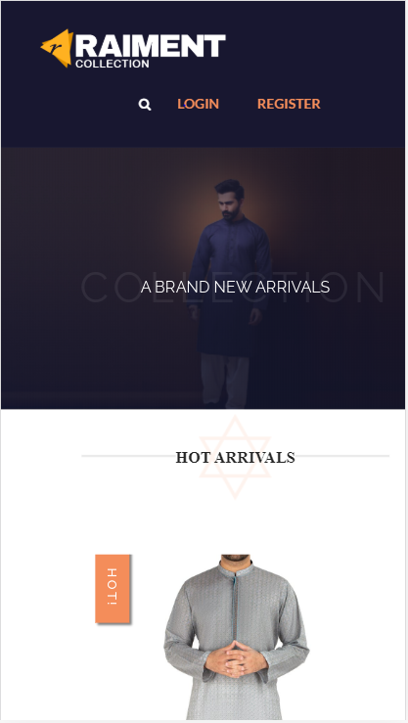

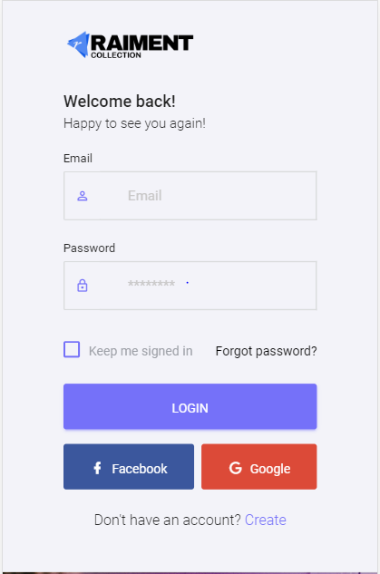

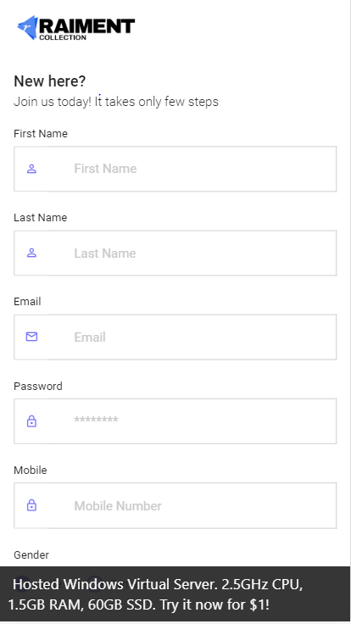

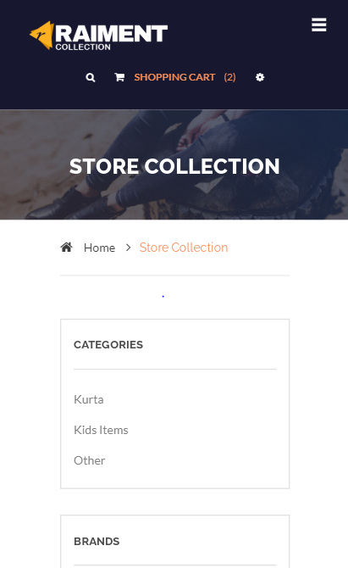

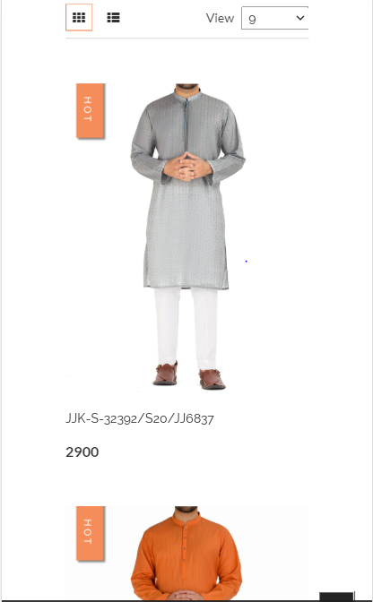

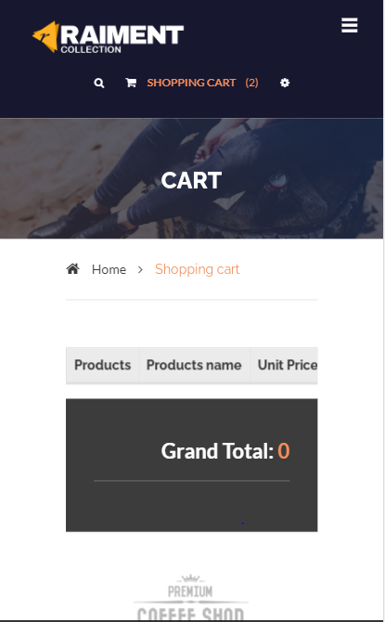

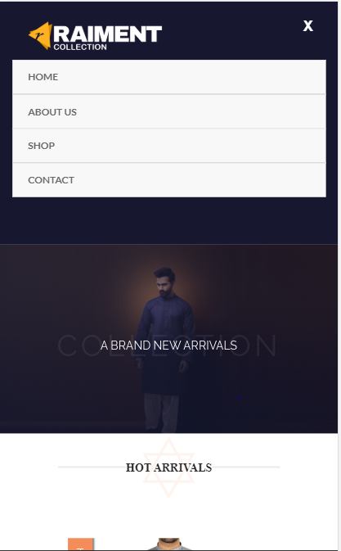

Website link: http://loveoffashion.somee.com/StoreHome

**COGNATIVE WALKTHROUGH**

**User’s Task!**

**1 - LOGIN**

* Will user achieve this goal

**YES**

* Is the user sure about the command that it be will execute correctly

**YES**

* Will user understand the feedback

**YES**

* Is action is visible

**YES**

**2 – Regsiter**

* Will user achieve this goal

**YES**

* Is the user sure about the command that it be will execute correctly

**YES**

* Will user understand the feedback

**YES**

* Is action is visible

**YES**

**2 – Regsiter**

**Select an item**

* Will user achieve this goal

**YES**

* Is the user sure about the command that it be will execute correctly

**YES**

* Will user understand the feedback

**YES**

* Is action is visible

**YES**

**3 - SELECT CATEGORY**

* Will user achieve this goal

**YES**

* Is the user sure about the command that it be will execute correctly

**YES**

* Will user understand the feedback

**YES**

* Is action is visible
* **YES**

**4 - CHOOSE OPTION**

* Will user achieve this goal

**YES**

* Is the user sure about the command that it be will execute correctly

**YES**

* Will user understand the feedback

**YES**

* Is action is visible

**YES**

**5 – Shopping Cart**

* Will user achieve this goal

**YES**

* Is the user sure about the command that it be will execute correctly

**NO**

* Will user understand the feedback

**YES**

* Is action is visible

**NO**

**6 - Logout**

* Will user from this goal

**YES**

* Is the user sure about the command that it be will execute correctly

**NO**

* Will user understand the feedback

**NO**

* Is action is visible

**NO**